Dear Family,

The Grade 3 students are beginning to study Unit 1: Addition and Subtraction Applications in Mathematics. Here is a little information about what your student will be learning in this unit.

What is the Focus of this Unit?

This unit builds upon what we learned last year in Grade 2 about the solving one- and two-step addition and subtraction story problems. We will use our understanding of addition and subtraction strategies with 2-digit numbers to solve problems. We will extend our 2nd grade skills and understandings into solving problems based upon scaled bar graphs and pictographs. This includes:
1) Reading scaled picture and bar graphs
2) Completing picture graphs based on given information
3) Making graphs based on given information
4) Posing a question, collecting data and representing the data in a graph
5) Solving one- and two-step problems “how many more” and “how many less” problems involving information presented in bar graphs

We will build upon our experience with studying standard units of length in grade 2 to understanding the concept of perimeter. This includes:
1) Counting perimeters of polygons on grids of square units
2) Measuring perimeters of polygons
3) Computing perimeters given the side lengths
4) Computing the missing length(s) of sides when we know the perimeter of the figure

Most importantly, we will learn to represent and solve problems about elapsed time. This includes:
1) Telling time to the minute
2) Solving for the elapsed time of an event when we know the start time and ending time
3) Solving for the ending time when we know the start time and the length of the event
4) Solving for the start time if we know the length of an event and the ending time

What are the mathematical practice expectations for my student?

Students will be expected to make sense of the real-world and mathematical problems and persevere in solving them by working collaboratively or independently. A major focus for the unit is interpretation of the mathematical models (graphs, diagrams, tables, equations, etc.) in the contexts of the problems.
They will use measurement tools and diagrams appropriately to gather data and solve problems.

How does this look different than what may have been taught in the past before the transition to the New Illinois Learning Standards for Mathematics?

Many of the expectations in this unit may seem similar to past expectations of Grade 3 students.
For example, students previously calculated perimeter given the side lengths. However, what is different with these expectations is that students may be given some information and asked to construct diagrams of all of the possible correct answers. (Sketch all of the possible rectangles that have a perimeter of 16.)

Students in Grade 3 have made bar graphs and picture graphs in the past. What may look different is that they will solve both one- and two-step problems involving information presented in bar graphs. (For example, How many fewer rows of tomato plants are there than the total of red pepper and green pepper plants?) They will also construct graphs given a scale. (For example, draw a bar graph in which each square in the bar graph might represent 5 pets.) The open-ended description allows for multiple right answers. These types of questions offer opportunities for students to come up with their own data sets, construct graphs that correspond to data sets or constraints, and justify their work. They also offer opportunities for students to engage in constructive dialogues that critique graphs and data sets.

You will see your student using number line diagrams for elapsed time. Here are some examples:
1) What time should we leave if we have to be at a movie at 11:15 a.m. and the movie theater is 20 minutes from our house?
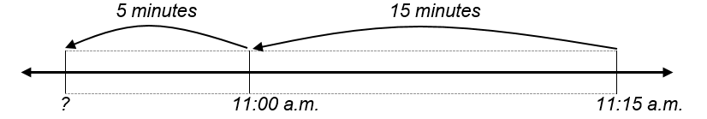
2) How long are we at the movie theater if we arrive at 11:15 a.m and leave at 12:55 p.m.?
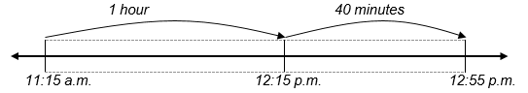

How will my student apply what he/she learns in the future?

All of the expectations of this unit will be foundational for multi-step problem solving in future grade levels. The practice with elapsed time will be built upon in future grade levels as students use number line models and tables for measurement conversions and problem solving in situations regarding measurements. This unit involves real-world application of addition and subtraction within 100.

How can you help your student at home?

One of the best things you can do during this unit is to ask your student to explain the models he/she is creating or interpreting to you. By explaining the models, students share their understanding of the mathematics and their strategic reasoning when solving problems. You may ask some real-life problems regarding time, like what time you should leave if you need to be somewhere by a certain time, if you know that the drive usually takes 20 minutes.

You can also play fluency games with your student to solve addition or subtraction with two-digit numbers. Students may do these using number lines as well, to show their reasoning.

What are the vocabulary terms that will be addressed?

Elapsed Time - the length of time for an event (from start time to ending time)
Model - a mathematical representation of a real-world or mathematical situation
Scale (of graph) - The numbers used to describe the intervals in a bar graph or the value of the pictures in a pictograph.
Pictograph - a graph that uses pictures to represent quantities of data, where each picture represents a set quantity
Bar Graph – a graphic display of data using vertical or horizontal bars whose lengths are proportional to the values of the elements in the data set
Perimeter – the path that surrounds a two-dimensional figure
Table – a collection of related data organized in rows and columns

Helpful resources:
Picture and Bar Graphs:
· Let’s Make a Picture Graph by Robin Nelson (Book)
· Bar Graphs (Making Graphs) Vijaya Khisty Bodach (Book)
· Lemonade for Sale by Stuart Murphy (Book)
· https://learnzillion.com/lessonsets/655 (Web Videos)
Perimeter:
· Racing Around by Stuart Murphy (Book)
· Spaghetti and Meatballs for All by Marilyn Burns and Debbie Tilly (Book)
· https://learnzillion.com/lessonsets/125 (Web Videos)

Telling Time to the Minute:
· Telling Time by Jules Older (Book)
· https://learnzillion.com/lessonsets/139 (Web Videos)

Elapsed Time
https://learnzillion.com/lessonsets/173 (Web Videos)

